**Facade design Pattern**

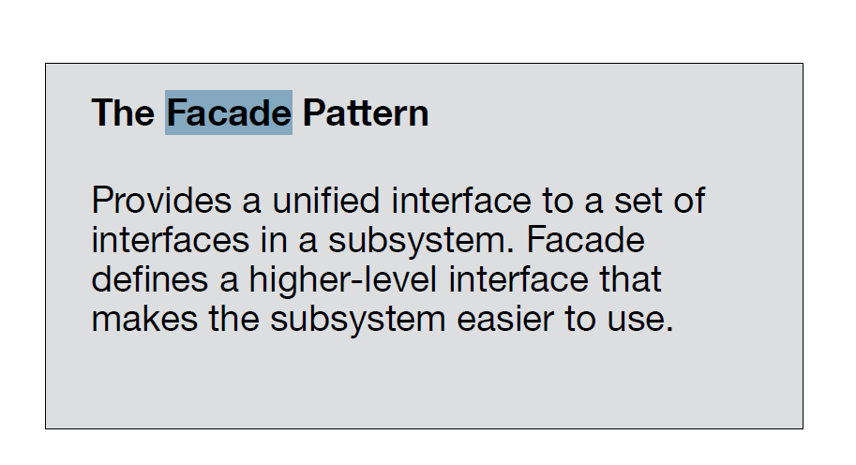

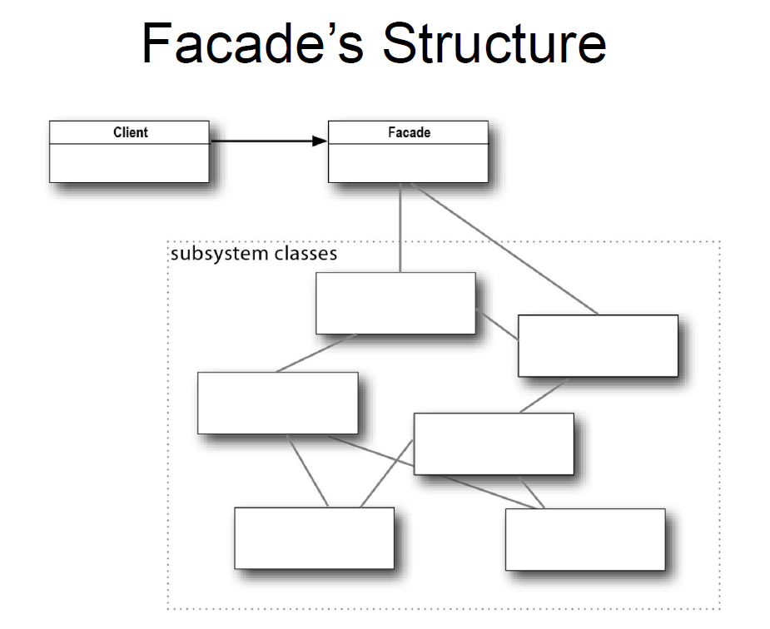

## Example:-

## Simple interface for a complex video conversion library

In this example, the Facade simplifies communication with a complex video conversion framework.

The Facade provides a single class with a single method that handles all the complexity of configuring the right classes of the framework and retrieving the result in a correct format.